Valdosta Urbanized Area Transit Implementation Report

Southern Georgia Regional Commission Valdosta-Lowndes MPO

4/5/2017

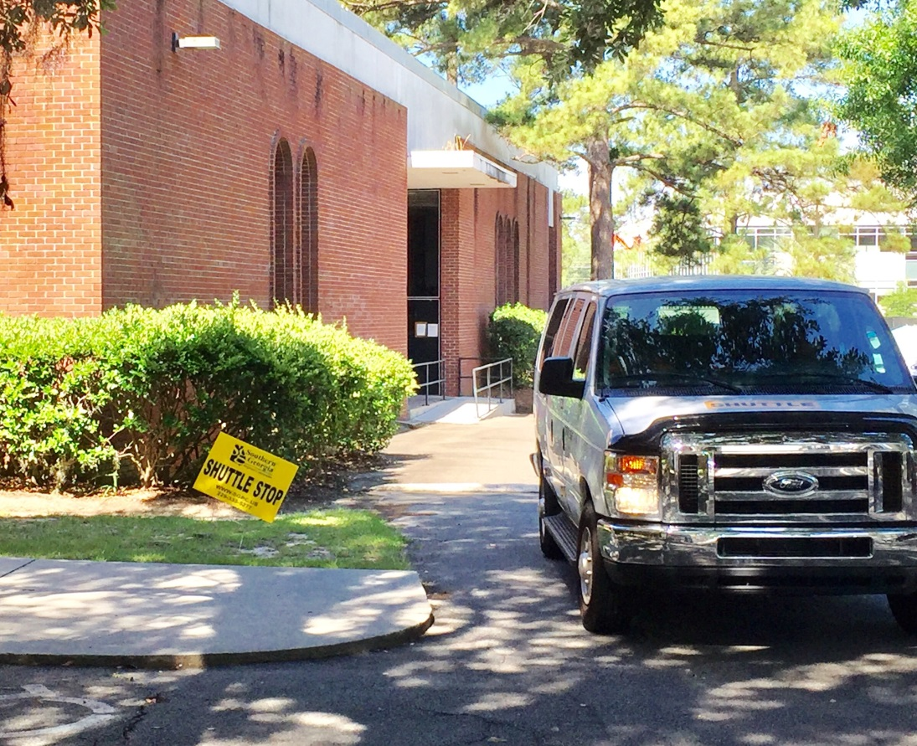

*The contents in this publication reflect the views of the author(s), who is (are) responsible for the facts and accuracy of the data presented herein. The opinions, findings, and conclusions in this publication are those of the author(s) and do not necessarily reflect those of the Department of Transportation, State of Georgia, the Federal Highway Administration, or the Federal Transit Administration. This publication does not constitute a standard, specification or regulation.*

*This document is prepared in cooperation with the Georgia Department of Transportation, the Federal Highway Administration and Federal Transit Administration.*

*VLMPO fully complies with Title VI of the Civil Rights Act of 1964 and related statutes and regulations in all programs and activities. VLMPO’s website (www.sgrc.us/transportation) may be translated into multiple languages. Publications and other public documents can be made available in alternative languages or formats, if requested.*

Contents

Executive Summary 2

Part 1: The Pilot Shuttle Program Evaluation 3

National Recognition 13

National Transit Database Comparison 14

Part 2: Estimating Costs and Benefits of Public Transit 15

Transportation Cost Savings 16

Low Cost Mobility Benefits 21

Cost-Benefit Ratio Findings 24

Part 3: Transit Funding and Implementation Options 26

Funding a Transit System 26

Conclusions 35

References: 36

Appendix A: Monthly Ridership Statistics 37

Appendix B: Transit Agency Profiles 46

Appendix C: Other uses of 5307 Capital Funds 49

Appendix D: Local Financial Obligation Breakdowns by Scenario 50

Appendix E: 5 Year Estimated Local Capital and Operation Expense Budgets 51

# Executive Summary

On October 15, 2015, the Georgia Department of Human Services (DHS), in partnership with the Southern Georgia Regional Commission (SGRC) began a pilot shuttle program geared toward reducing barriers in transportation for those seeking integration into the workforce and full participation in society. By targeting known DHS service sites and clients, as well as the public in Census tracts with high Environmental Justice (minority and low-income) populations, the shuttle service began using Federal Transit Administration 5316 Job Access Reverse Commute (JARC) and 5317 “New Freedom” funds to allow the public to ride free of charge. Since its inception, the Pilot Shuttle Program has registered over 1,200 citizens and seen month-over-month increases in average daily ridership and trip numbers. During its operation, the Pilot Shuttle Program was recognized with several state and national awards in innovation and transportation planning. It served 10,146 riders, provided 14,723 trips, and covered 67,701 miles in its 3,873 hours of operation. The following is a report and analysis of the Pilot Shuttle Program which includes ridership statistics, trip counts, popularity of each stop, shuttle rider survey results, as well as the estimated cost-benefit of the program.

Utilizing a National Center for Transit Research (NCTR) Cost-Benefit Analysis of Rural and Small Urban Transit report prepared for the US DOT, an estimation of cost and potential benefits was calculated for the Valdosta-Lowndes County area of a permanent public transit system, with figures from the Valdosta Transit Implementation Study prepared by Tindale Oliver and the Valdosta Pilot Shuttle Program. This section provides relevant excerpts from the NCTR report with examples showcasing the formulas and possible costs and benefits for each category. Based on these calculations, the Pilot Shuttle Program has a cost-benefit ratio of 1.01, while the Tindale Oliver cost-benefit ratio ranged from 0.81 to 2.01 based on the low and high estimates used. When estimated cost-benefit ratios are greater than 1, the results show that the benefits provided by transit services in small urban areas are greater than the costs of providing those services.

The third section examines the proposed implementation, funding sources (including 5307 Urban Area Transit funds, Purchase of Service contracts, the Capital Cost of Contracting, and other options) and the potential partnerships with third party transportation networking companies as suggested in the Tindale Oliver Transit Implementation report. Potential costs and funding options are explored using statistics and figures from the previous chapters of this report.

# Part 1: The Pilot Shuttle Program Evaluation

Aside from Valdosta State University’s on-campus bus service, Valdosta has not had fixed-route public transit since 1963, when a locally owned, private-sector bus company ceased its transit operations. There are other transportation options, including the Lowndes County Public Transit that operates a demand-response service with Federal Transit Administration (FTA) Section 5311 Rural Transit funds, and several taxi and private transportation companies. To begin exploring the feasibility of restoring fixed-route transit to Valdosta, the Southern Georgia Regional Commission (SGRC) in partnership with the Georgia Department of Human Services (DHS) launched a “pilot shuttle” service in October of 2015. This was a single-vehicle fixed-route service, using FTA Section 5316 Job Access Reverse Commute (JARC) and 5317 ‘New Freedom” funding awarded to SGRC from DHS that operated through December 2016.

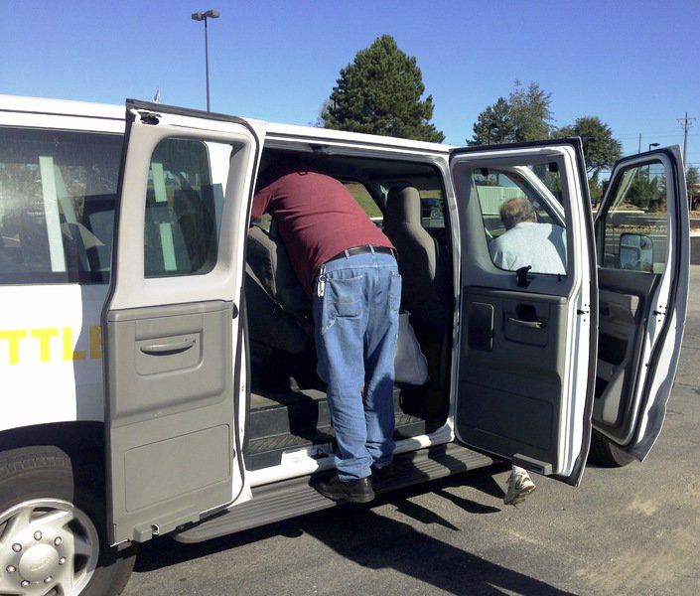

The shuttle route was selected based on an Environmental Justice Study conducted by students at Valdosta State University in 2015, which examined vehicular access, English proficiency, age distribution, income, poverty, race, and educational attainment as defined and measured by the U.S. Census. By targeting existing DHS service centers and clients as well as the public in Census tracts with high Environmental Justice populations, the shuttle service met the guidelines of the FTA funds, allowing the public to ride free of charge. During its tenure, the shuttle experienced 3 distinct route variations, in part due to rider feedback, changes in operating hours, and available funding from DHS. Even though this service was ultimately limited to one vehicle running a single loop on 90-minute headways, its ridership grew steadily, and indeed has helped illustrate the viability of permanent public transit in Valdosta.

The initial shuttle route focused on providing residents in the neighborhoods southeast of downtown Valdosta access to the major economic activity centers located North and West of downtown. The VSU Environmental Study indicated these areas as having the highest concentrations of elderly households, houses with no vehicular access, and low levels of income.

The following map shows the shuttle route and the usage, broken down by Total Activity and On/Off percentages, for each of the stops, proportionately scaled to show popular destinations.

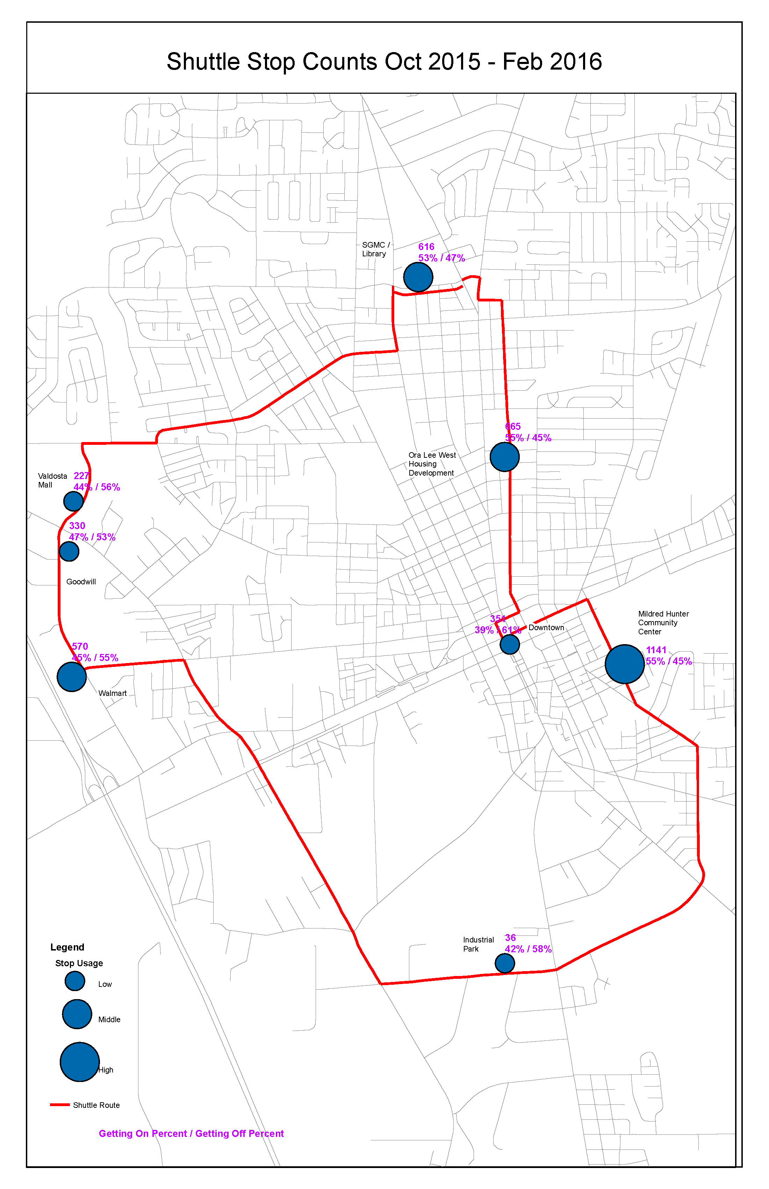

Figure Original Pilot Shuttle Route

In March of 2016, DHS was able to procure additional funding, ushering in a second phase of the shuttle program. This funding allowed the shuttle program to add a second shuttle and a “Northern Route” to the already existing loop, effectively doubling the size of the service area, and providing access to additional educational and employment resources. Several of the stops along the Northern Route were based on rider feedback and Human Service Provider input. The Northern Route and Southern Route saw a sharp increase in ridership from March through June, doubling average daily ridership statistics in the first month alone from 15 riders per day to 30.

Figure Average Daily Ridership of North and South Routes

**Northern Route Added**

Figure Combined Average Daily Ridership by Month

The following map shows the North (blue) and South (yellow) routes and their stops again by usage, Total Activity, and On/Off percentages, proportionately scaled to show popular destinations.

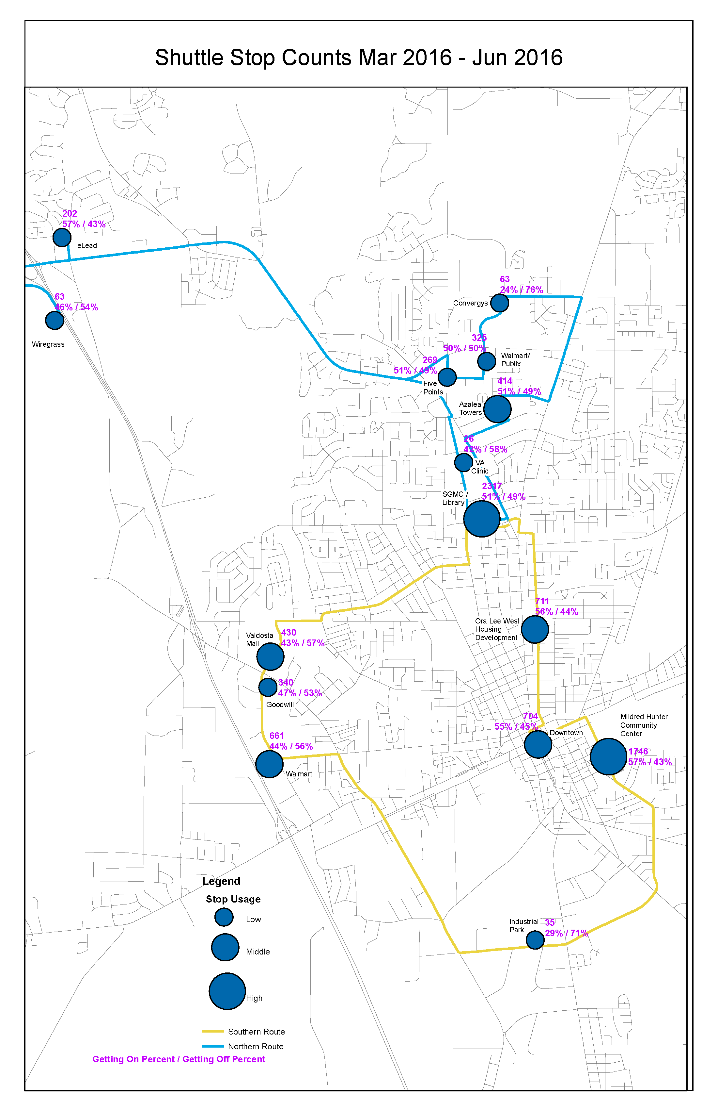

Figure Map of North and South Shuttle Routes

Beginning in July of 2016, the shuttle program experienced a reduction in available funding from DHS, and the routes had to be modified to accommodate these changes. The new route would combine the North and South loops into a figure-eight route, eliminating the stops at eLead1/Fresh Beginnings and Wiregrass Georgia Technical College, while utilizing one shuttle to operate on a 90 minute headway. This combined route allowed for maximum service coverage without drastically increasing the service delivery wait times.

During the final phase of the pilot program, the funding available was only guaranteed for several months at a time; initially extending the program from June 30,2016 to September 30, 2016, and then again to December 31, 2016. This had an impact on ridership during the final months of service, as indicated in the chart below by the sudden dips and rises in Average Daily Ridership:

Average Daily Ridership is calculated using the number of unique riders per day. A unique rider is defined as a physical person, and is only counted once per day.

Figure Average Daily Ridership of Pilot Shuttle Program

The combined route is shown with the popularity, Total Activity, and On/Off percentages for the final phase of the program. The SGMC Regional Library was utilized as the epicenter of the route causing the shuttle to stop twice at this location during the 90 minute loop.

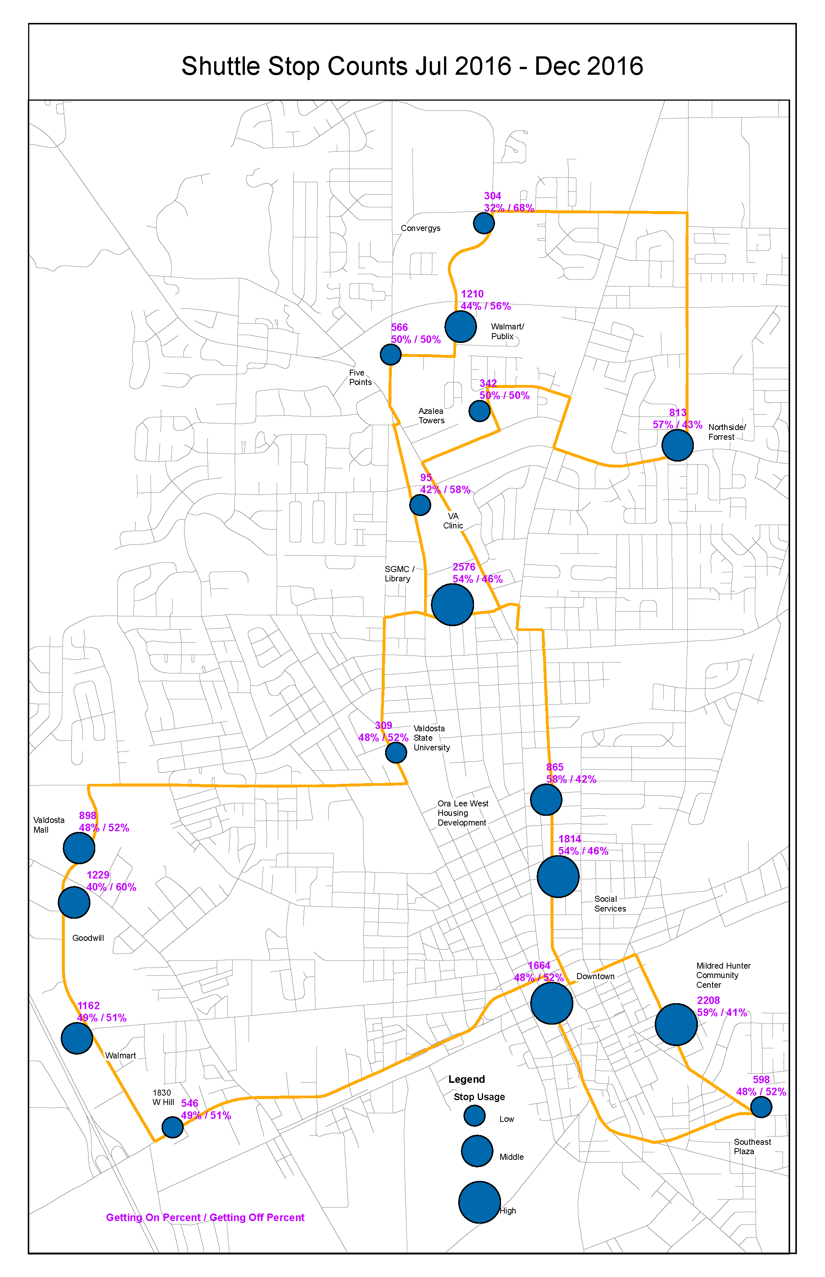

Figure Map of the Combined Shuttle Route

The pilot shuttle provided citizens access to many resources throughout the community, and filled a transportation gap in an area without traditional urban transit options. Popular destinations, like Walmart, Goodwill, South Georgia Medical Center and Regional Library, and Downtown Valdosta with its numerous retailers and service providers within a half mile walking distance, allowed people to access jobs, workforce training, medical care, educational opportunities, as well as shopping and other daily needs.

Figure Survey Results of Shuttle Stop Usefulness

A survey of riders was taken during the final weeks of the pilot shuttle service to gain insight into the riding habits and purposes for their trips. The results showed that 48% of the riders utilized the shuttle daily, while another 38% rode 2-4 times per week. Survey responses also indicated that the shuttle stop locations were considered “Somewhat” or “Extremely” useful to the riders.

Figure Survey Results of Shuttle Usage

Combined with the Shuttle’s average on-time rate of 95%, the Shuttle proved to be an efficient way to travel, arriving within a ± 5 minute window of the scheduled stop times. On-time percentages were calculated once the route adjustments were finalized in August 2016, allowing drivers and riders ample time to acclimate to the new route and schedule. Traffic delays during holidays were the main cause for decreases in the shuttle’s timeliness.

Figure Average On-Time Percentage of the Pilot Shuttle

According to the survey respondents, 31% said they rode the shuttle to work, 28% used it to go shopping, 16% as a means to look for work, 15% for medical purposes, and 10% for educational reasons. As the experience with the pilot shuttle indicated, the opportunity for transit to be the linkage to employment is especially true for lower-wage workers and for adults who have not been able to maintain a steady work history in the absence of transit. A permanent transit system that links otherwise-unemployed individuals to their jobs might be less than the cost of providing housing and supportive services to adults whose lack of transportation is the primary reason they are not in the workforce. This would be a low-cost mobility benefit, and is examined on page 21 of this report.

Figure Survey Results of Purpose for Riding the Shuttle

The DHS funding for the shuttle allowed consumers to ride free of charge throughout the duration of the pilot program. When surveyed, the majority of riders indicated they would be willing to pay for a monthly pass option, while another third indicated a willingness to pay $1 per trip. The amount of a monthly pass would be determined by policy makers, should a permanent transit system be implemented.

Figure Survey Results of Amount Willing to Pay per Trip on a Permanent Transit System

Other cities throughout the state offer monthly passes for transit riders, which range in price from $30 to $95. They also offer senior or reduced rates for passengers who meet certain criteria.

## National Recognition

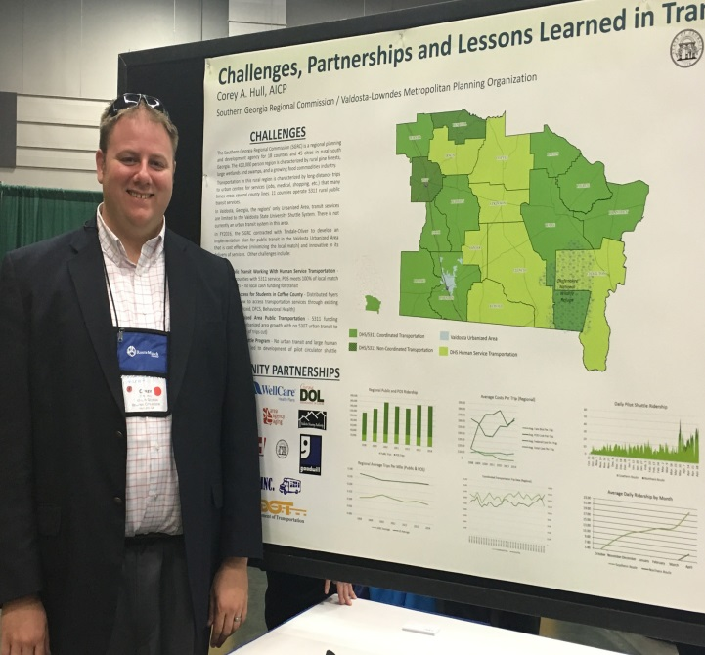During the 14 months of operation, the Pilot Shuttle Program was recognized with several state and national awards for innovation and transportation planning. Members of the SGRC were asked to present at state and national conferences about the challenges and successes of the program.

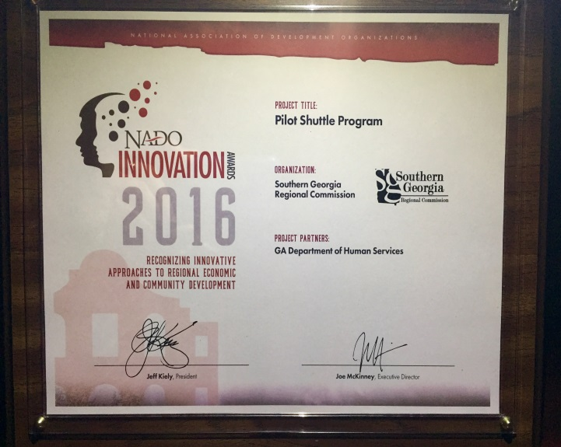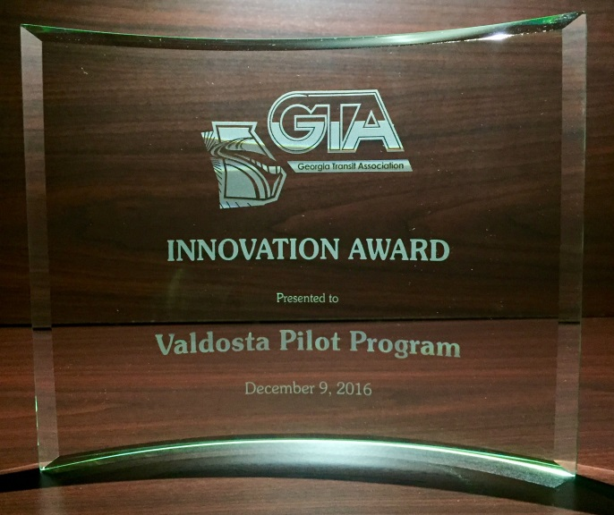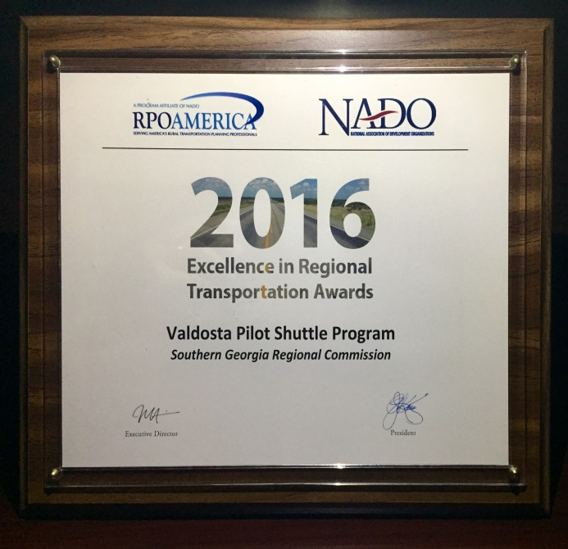

Corey Hull presents a “poster session” at the CTAA national conference in Portland, OR

The Georgia Transit Association recognizes the innovative strategy and increased performance of transit in the Valdosta-Lowndes County area

The Shuttle’s innovative use of DHS funding to meet the goals of the Coordinated Transportation program and local Common Community Vision

The Shuttle is recognized for its outstanding efforts in planning and implementation

## National Transit Database Comparison

If the shuttle program had been reported to the National Transit Database (NTD) as other cities with existing urban transit programs do, the operational costs would be comparable. The largest differentiator of the cities listed below is the number of Unlinked Passenger Trips; the Shuttle reported 14,726, Hinesville reported 16,255, Albany reported 1,036,749, and Lowndes County Public Transit reported 37,463. The Lowndes County figures are for the demand-response riders and clients of DHS under the Coordinated Transportation program. They are shown as a point of reference for the current public transit options in Valdosta-Lowndes County.

|  |  |  |  |  |
| --- | --- | --- | --- | --- |
| **Operating Cost Comparison** | 1 Bus | 3 Buses | 8 Buses | 8 Buses |
| **Shuttle** | **Hinesville** | **Albany** | **Lowndes** |
| Op. Exp. per Vehicle Rev. Miles | $ 3.97 | $ 5.94 | $ 4.03 | $ 1.39 |
| Op. Exp. Per Vehicle Rev. Hours | $ 69.43 | $ 75.51 | $ 65.62 | $ 19.84 |
| Op. Exp. Per Unlinked Pass. Trip | $ 18.26 | $ 38.34 | $ 2.23 | $ 11.80 |
| Unlinked Pass. Trip per Rev. Miles | 0.22 | 0.20 | 1.81 | 0.12 |
| Unlinked Pass. Trip per Rev. Hours | 3.80 | 2.00 | 29.50 | 1.68 |

Pilot Shuttle Expenses if reported to NTD

|  |  |  |  |  |
| --- | --- | --- | --- | --- |
| **Operating Cost Comparison w/SGRC Admin Costs** | 1 Bus | 3 Buses | 8 Buses | 8 Buses |
| **Shuttle** | **Hinesville** | **Albany** | **Lowndes** |
| Op. Exp. per Vehicle Rev. Miles | $ 5.77 | $ 5.94 | $ 4.03 | $ 1.39 |
| Op. Exp. Per Vehicle Rev. Hours | $ 100.95 | $ 75.51 | $ 65.62 | $ 19.84 |
| Op. Exp. Per Unlinked Pass. Trip | $ 26.55 | $ 38.34 | $ 2.23 | $ 11.80 |
| Unlinked Pass. Trip per Rev. Miles | 0.22 | 0.20 | 1.81 | 0.12 |
| Unlinked Pass. Trip per Rev. Hours | 3.80 | 2.00 | 29.50 | 1.68 |

This table shows the same NTD reporting, with the SGRC’s administrative costs factored into the Operating Expense category

It should be noted that the term “bus” in the tables does not indicate the same type of vehicle. The Shuttle used a 15-passenger van, while Hinesville, Albany, and Lowndes use a mixed fleet of vehicles ranging from passenger vans, ADA wheelchair cutaway vans, to 30- and 40-passenger heavy-duty buses. These vehicles have different operating costs and might impact the overall operating costs for each system.

Monthly ridership reports for the shuttle and Transit Agency Profiles for the comparison cities can be found in the appendix.

# Part 2: Estimating Costs and Benefits of Public Transit

Utilizing a National Center for Transit Research Cost-Benefit Analysis of Rural and Small Urban Transit report prepared for the US DOT, an estimation of cost and potential benefits was calculated for the Valdosta-Lowndes County area, with figures from the Valdosta Transit Implementation Study prepared by Tindale Oliver and the Valdosta Pilot Shuttle Program, as well as national survey responses and other studies. The table below provides a summary of the calculations, which are explained in further detail in this section. When estimated cost-benefit ratios are greater than 1, the results show that the benefits provided by transit services are greater than the costs of providing those services. These numbers do not include complementary paratransit costs that would be required under a permanent system.

|  |  |  |  |  |
| --- | --- | --- | --- | --- |
|  | **Tindale Oliver**  **Low Estimates** | **Tindale Oliver**  **High Estimates** | **Pilot Shuttle Costs** | **Shuttle w/ SGRC Admin Costs** |
| Gross Benefits per Trip | $ 27.19 | $ 27.00 | $ 28.56 | $ 28.56 |
| Operating Costs per Trip | $ 22.78 | $ 9.17 | $ 18.26 | $ 26.55 |
| Net Benefits per Trip | **$ 4.41** | **$ 17.83** | **$ 10.30** | **$ 2.01** |
| Total Benefits | $ 580,606.67 | $ 1,649,395.08 | $ 270,515.33 | $ 270,515.33 |
| Operating Costs | $ 720,000.00 | $ 820,000.00 | $ 268,898.00 | $ 390,912.00 |
| Benefit to cost ratio | 0.81 | 2.01 | 1.01 | 0.69 |

Estimating the benefits of public transit first requires an estimate of how transit riders would respond if transit service was not available. Estimates must be made for the percentage of riders who would drive themselves, get a ride from someone else, use a taxi, walk or bike, or forego the trip. This report uses results from previously conducted surveys of transit riders to predict the behavior of transit users in the absence of transit for small urban areas.

Figure Rider Behavior in the Absence of Transit Options

The transit benefits in small urban and rural communities are primarily categorized as transportation cost saving benefits, low-cost mobility benefits, and economic impact benefits. If transit is not provided in a community, then transit riders would have to either use a different mode or forego the trip. Transportation cost savings are the savings that result when individuals are able to use transit in place of another mode, and affordable mobility benefits are the benefits that result when trips are made that would otherwise be foregone in the absence of transit. Economic benefits (direct, indirect, and induced) result from the economic activity generated by transit operations. The economic impacts of transit operations were not included within the cost-benefit ratio estimation. This report focuses on the transportation cost savings and low-cost mobility benefits under the proposed permanent transit system by Tindale Oliver.

## Transportation Cost Savings

Transportation cost savings were calculated for vehicle ownership and operating costs, chauffeured costs of riding with someone, taxi fare costs, and bicycling or walking. These costs were compared to that of using public transit to calculate the transportation cost saving benefits.

1. Vehicle Ownership and Operating Costs

People who live in households without a personal vehicle are another key audience whose lives are much improved by the availability of transit. Within the city of Valdosta, more than 3,700 people (nearly 7 percent of the city’s population) do not have a personal vehicle in their household; even outside the city limits, the lack of vehicle availability is noticeable, with a total of more than 5,500 county residents (or nearly 5 percent of the county’s population) living in zero-car households. Even residents with a vehicle might find the use of transit to be a more viable economic solution, as the average cost to own and operate can be a burden.

Vehicle ownership and operating costs are calculated for transit riders who decide to use a personal automobile in the absence of transit. Using the High and Low estimates from the Tindale Oliver report, this figure is estimated to be 12.8%, or 4,045 trips per year. These costs can be understood as the money that is saved by using public transportation instead of driving a personal automobile.

Considering that on an average, vehicle owners drive 15,000 miles per year, the vehicle ownership and operation cost for an average U.S. driver is estimated as $0.65 per mile, which is the average of values for all the vehicle types from the AAA data for 2013. The average trip distance for an urban area is calculated at 3 miles. These values are used in this analysis for calibrating the vehicle ownership and operation costs.

|  |  |  |  |
| --- | --- | --- | --- |
| **Vehicle Type** | **10,000 miles per year** | **15,000 miles per year** | **20,000 miles per year** |
| Small sedan | 59.5 ¢ | 46.4 ¢ | 39.8 ¢ |
| Medium sedan | 78.0 ¢ | 61.0 ¢ | 52.3 ¢ |
| Large sedan | 97.5 ¢ | 75.0 ¢ | 63.5 ¢ |
| 4WD SUV | $1 | 77.3 ¢ | 65.7 ¢ |
| Mini van | 84.0 ¢ | 65.3 ¢ | 55.7 ¢ |

Source: AAA, Your Driving Costs, 2013 http://newsroom.aaa.com/wp-content/uploads/2013/04/YourDrivingCosts2013.pdf

The formula for calculating Vehicle Ownership and Operation Costs is:

*$[trips made in personal car x average trip length x $0.65]*

|  |  |  |  |
| --- | --- | --- | --- |
| **Use Personal Vehicle** | | | |
|  | [(Trips x %) x Avg. Trip Dist. x $0.65] | [(Trips x %) x Avg. Trip Dist. x $0.33] |  |
| **T.O. Estimates** | **Cost to Own & Operate** | **Transit** | **Net Savings** |
| Annual Costs | $7,887.36 | $3,640.32 | $4,247.04 |
| Cost per Trip (Annual Cost/% of Trips) | $1.95 | $0.90 | $1.05 |

1. Chauffeured Costs of Riding with Someone

While some will drive themselves in the absence of transit, many cannot drive or do not have access to an automobile and will get a ride from someone else, such as a family member or friend. Chauffeuring trips are additional automobile trips made specifically for a passenger (Litman 2012). Chauffeuring trips excludes ride sharing because these trips will be made anyway whether or not there are additional passengers in the vehicle (Litman 2012). These chauffeuring trips can be expensive, inefficient and burdensome for the driver. According to Litman (2012), rider surveys indicated that among the transit riders who would choose to travel as automobile passengers in the absence of transit, half of the trips are rideshare trips, meaning the remaining half are chauffeured trips .

|  |  |  |  |
| --- | --- | --- | --- |
| **Ride with Someone /**  **Chauffeured Cost** | | | |
|  | [(Trips x 50%) x Avg. Trip Dist. x $1.05] | [(Trips x %) x Avg. Trip Dist. x $0.33] |  |
| **T.O. Estimates** | **Chauffeured Costs** | **Transit** | **Net Savings** |
| Annual Cost | $ 11,347.56 | $ 10,807.20 | $ 540.36 |
| Cost per Trip (Annual Cost/% of Trips) | $ 1.58 | $ 1.50 | $ 0.08 |

1. Taxi Fare Savings

Taxi trips can be very expensive. The HDR cost-benefit study for South Dakota public transit used a taxi base fare of $2.23 for urbanized areas and $8.00 for small urban areas per taxi trip for their analysis (HDR Decision Economics 2011). Litman (2012) suggested an average taxi fare of $2.25 per mile to determine the avoided taxi trips cost savings. Therefore, average taxi fare of $2.25 per mile was used to calculate the cost savings from taxi trips for small urban and rural areas. This rate is comparable to local taxi companies currently operating in Valdosta-Lowndes County

|  |  |  |  |
| --- | --- | --- | --- |
| **Taxi Fare Costs** | | | |
|  | [(Trips x Avg. Trip Dist. x $2.25] | [(Trips x Avg. Trip Dist. x $0.33] |  |
| **T.O. Estimates** |  | **Transit** | **Net Savings** |
| Annual Cost | $ 24,956.10 | $ 3,327.48 | $ 21,628.62 |
| Cost per Trip (Annual Cost/% of Trips) | $ 6.75 | $ 0.90 | $ 5.85 |

1. Travel Time Savings

In addition to out-of-pocket costs, there are additional costs associated with travel, such as the amount of time devoted to travel. Because travel times differ between transit and other modes, these differences need to be taken into consideration when valuing the benefits of transit.

The basic procedure followed to tabulate the travel time savings for each mode is to multiply the following parameters for all transit trips and for trips by alternative modes in the absence of transit: number of trips made, average travel time, and cost of travel time per hour.

|  |  |  |  |
| --- | --- | --- | --- |
| **Cost of Travel Time** | | | |
|  | [# of Trips x Avg. Travel Time x Rate) | [# of Trips x Avg. Travel Time x Rate) |  |
|  |  | **Transit** | **Net Savings** |
| Drove a Car | $ 1,160.06 |  | $ 1,160.06 |
| Rode with Someone | $ 2,272.99 |  | $ 2,272.99 |
| Taxi | $ 1,166.40 |  | $ 1,166.40 |
| Walk | $ 31,639.50 |  | $ 31,639.50 |
| Bike | $ 1,599.75 |  | $ 1,599.75 |
| **Total Costs** | **$ 37,838.71** | **$ 26,340.40** | **$ 11,498.31** |
| **Cost per trip** | **$ 1.20** | **$ 0.83** | **$ 0.36** |

1. Crash Cost Savings

Transit is a relatively safe mode of travel. The fatality rate for transit users is very low when compared to that of car occupants (one tenth of the rate for car occupants) (Litman 2012). Measuring the value of transit requires an estimate of the value it provides by reducing crash costs. Litman (2012) used a crash cost of 10¢ per vehicle mile in his analysis, in which 6¢ is internal and 4¢ is external; internal being borne by the individual, external by the community. Litman (2012) estimated the average crash cost of a bus as 28.9¢ per bus-mile, considering 5.2 average passengers and one driver and also considering the risk for the other road users. A crash cost of 10¢ per vehicle mile was used for automobiles, including those driving personal vehicle, riding with someone else, and using a taxi if transit did not exist.

When transit is not available, the crash costs were calculated by multiplying the total number of trips by mode by 6 miles (to account for round trips) and by the crash cost per mile for all the alternatives The Total Costs were then divided by 24,806 (31,600 estimated trips minus the 6,794 who Wouldn’t Make the Trip) since there is no crash costs associated with not going. The transit crash cost was calculated by dividing the number of trips for each alternative by 5.2 (an average bus load) then multiplying by 6 miles (to account for round trips) and by the crash cost per mile of transit. The Total Transit Costs were then divided by the 31,600 estimated trips since transit would be available. The crash cost difference between the alternative modes and the transit modes determines if there are any crash cost savings attributable to using transit.

|  |  |  |  |
| --- | --- | --- | --- |
| **Crash Costs** | | | |
|  | (Trips by Mode x 6 miles x Crash Cost per Mile) | ((Trips by Mode / 5.2) x 6 miles x Crash Cost per Mile) |  |
|  | **Total Alternatives ($0.10)** | **Transit ($0.289)** | **Net Savings** |
| Drove a Car | $ 2,426.88 | $ 1,348.79 | $ 1,078.09 |
| Rode with Someone | $ 4,322.88 | $ 2,402.52 | $ 1,920.36 |
| Taxi | $ 2,218.32 | $ 1,232.87 | $ 985.45 |
| Walk | $ 5,062.32 | $ 2,813.48 | $ 2,248.84 |
| Bike | $ 853.20 | $ 474.18 | $ 379.02 |
| **Total Costs** | **$ 14,883.60** | **$ 8,271.85** | **$ 6,611.75** |
| Cost per trip | **$ 0.60** | **$ 0.26** | **$ 0.34** |

## Low Cost Mobility Benefits

To estimate low-cost mobility benefits, the costs of trips that would be foregone in the absence of transit, such as missed health care trips or missed work trips, were estimated. Foregone trips were categorized as medical trips, work trips, and other trips, and different methodologies were used for each. The total number of foregone trips by trip purpose was determined using the trip alternative and trip purpose data presented in the previous sections.

1. Medical Trips

The benefit from providing a trip for medical purposes is the difference between well-managed and poorly-managed care, which can include a reduction in more costly care and improved quality of life. Calculations from a spreadsheet tool developed by Hughes-Cromwick et al. (2005) were used to estimate this benefit. Assumptions regarding the percentage of adult users of NEMT services who have different chronic conditions or require preventive care, as well as the number of office visits required for each, are shown in the table below. These estimates are national norms identified by Hughes-Cromwick et al. (2005). The benefits of NEMT trips are calculated as the cost difference between well-managed and poorly-managed care, plus improvements in quality of life, minus costs of additional medical treatment incurred, divided by the number of trips required. Using the tool developed by Hughes-Cromwick et al. (2005), results in a net benefit of $713 per round trip, or $357 per one-way trip. Therefore, this is assumed to be the cost of foregone medical trips. The total number of foregone medical trips was multiplied by $357 to determine the total cost of foregone medical trips.

|  |  |  |
| --- | --- | --- |
| Types of Health Care Trips and Number of Trips Required Per Year | | |
| Health Care Trip Purpose | % of Adult NEMT Population | Office Visits Per Year |
| *Chronic Condition* |  |  |
| Asthma | 20% | 8.83 |
| COPD | 19% | 9.86 |
| Diabetes | 15% | 13.00 |
| End Stage Renal Disease | 7% | 115.03 |
| Congestive Heart Failure | 26% | 18.94 |
| Hypertension | 37% | 11.14 |
| Mental Health | 50% | 14.82 |
| *Preventive Visits* |  |  |
| Cancer Screening | 12% | 2.0 |
| Currently Pregnant | 2% | 12.0 |
| Dental Problems | 28% | 2.0 |
| Vaccinations | 20% | 1.0 |

|  |  |
| --- | --- |
| **Foregone Medical Trips** |  |
|  | Tindale Oliver Low Estimates |
|  | ((Foregone x Purpose %) x $357) |
| Total Cost of Foregone Medical trips | $ 373,147.38 |
| Cost per trip | $ 11.81 |

1. Work Trips

A four-person household receiving Temporary Assistance for Needy Families (TANF) and Supplemental Nutrition Assistance Program (SNAP) assistance could result in $24,400 in state and federal expenditures. These are costs that could potentially be avoided by providing transit services to transportation-disadvantaged individuals. Providing transit to work for one individual for a year would require approximately 500 trips, or two trips per day (one trip to work and a return trip home) for 250 working days per year. If providing these 500 trips allows the individual to keep a job and not require government assistance, government payments would be reduced by $24,400 per year, or approximately $49 per trip. In most cases, this is significantly greater than the expense of providing the transportation.

|  |  |
| --- | --- |
| **Foregone Work Trips** |  |
|  | Tindale Oliver Low Estimates |
|  | ((Foregone x Purpose%) x $49 |
| Total Cost of Foregone Work Trips | $ 102,432.62 |
| Cost per trip | $ 3.24 |

1. Other Trips

The cost of foregone trips for other trip purposes is calculated using the concept of consumer surplus. Consumer surplus is the difference between the maximum price a consumer is willing to pay and the price they actually do pay. Providing transit service increases consumer surplus by decreasing the amount users must pay for a trip.



Consumer Surplus Supply and Demand Model

In the graph above, P₁ is the price travelers would pay for a trip in the absence of transit. This price represents the least costly alternative available, which could be the cost per trip of owning and operating an automobile, getting a ride from someone else, using a taxi, etc. At this price, the number of trips taken is Q₁. P₀ represents the transit fare, or the price to travel by transit. By introducing transit, the price of travel decreases from P₁ to P₀, and the number of trips increases from Q₁ to Q₀. The difference between Q₁ and Q₀ is the number of trips that would be foregone in the absence of transit.

Determining the cost of a foregone trip, therefore, requires information about transit fares (P₀) and the cost of traveling by the most likely alternative (P₁). For this report, the lowest cost alternative was found to be Ride With Someone, at $1.58 per trip, compared to Drive Own Car at $1.95 per trip, and Take a Taxi at $6.75 per trip. The Transit Fare was the recommended $1.00 per trip from the Tindale Oliver study.

When price decreases from P₁ to P₀, the increase in consumer surplus is (P₁ – P₀)*Q₁ + 0.5*[(P₁-P₀)*(Q₀-Q₁)], which is equal to A + B in the graph. Area A is the benefit consumers achieve by having access to an alternative mode of travel that costs less than the mode they would use in the absence of transit. Area B represents consumer surplus resulting from new trips that are made that would have been foregone in the absence of transit.

|  |  |  |
| --- | --- | --- |
| **Foregone Other Trips** | | |
|  | (P₁-P₀)*Q₁+ 0.5((P₁-P₀)*(Q₀-Q₁)) | 0.5*(P₁-P₀) |
|  |  |  |
|  | Increase in Consumer Surplus | Per Trip |
| vs. Driving a Car | $ 7,069.90 | $ 0.48 |
| vs. Riding with Someone | $ 6,096.15 | $ 0.29 |
| vs. Taxi Ride | $ 40,790.50 | $ 2.88 |
|  | **$ 53,956.55** | **$ 3.64** |

It can reasonably be assumed that for those who forego trips in the absence of transit, the cost of other modes of travel are high. Many of these individuals cannot drive, do not have access to an automobile, and do not have easy access to someone who can give them a ride.

## Cost-Benefit Ratio Findings

When the Transportation Cost Savings and Low-Cost Mobility Benefits were finally calculated, the benefit to cost ratio was able to be determined. This ratio was calculated using the low and high trip counts and operating costs outlined in the Tindale Oliver report, as well as for the pilot shuttle program with and without the SGRC administrative costs.

|  |  |  |  |  |
| --- | --- | --- | --- | --- |
|  | **Tindale Oliver**  **Low Estimates** | **Tindale Oliver**  **High Estimates** | **Pilot Shuttle Costs** | **Shuttle w/ SGRC Admin Costs** |
| Gross Benefits per Trip | $ 27.19 | $ 27.00 | $ 28.56 | $ 28.56 |
| Operating Costs per Trip | $ 22.78 | $ 9.17 | $ 18.26 | $ 26.55 |
| Net Benefits per Trip | **$ 4.41** | **$ 17.83** | **$ 10.30** | **$ 2.01** |
| Total Benefits | $ 580,606.67 | $ 1,649,395.08 | $ 270,515.33 | $ 270,515.33 |
| Operating Costs | $ 720,000.00 | $ 820,000.00 | $ 268,898.00 | $ 390,912.00 |
| Benefit to cost ratio | 0.81 | 2.01 | 1.01 | 0.69 |

The majority of the benefits came from the low-cost mobility benefits, which accounted for 70% of the total Gross Benefits per Trip. This indicates that low-cost mobility trips are a vital part of the transit service. Medical trips were shown to have the highest single benefit at $11.81 per trip. Given the average trip distance of 3 miles, the second highest benefit came from transportation cost savings compared with taxi services, at $5.76 per trip.

Small urban transit in United States is observed to have total transportation cost savings and low-cost mobility benefits totaling $3.7 billion in 2011, among which $3.4 billion (93.4%) were observed in fixed-route bus and $244 million (6.6%) were observed in demand-response service. Further, low-cost mobility benefits constitute the highest proportion of total benefits in fixed-route bus service (85%) and demand-response service (92.5%), showing again the importance of providing trips to those who otherwise would not be able to travel. The average transit benefits per trip in small urban areas is observed as $10.43, where fixed-route service has an average benefits of $10.23 per trip and demand-response service has an average benefit of $14.31 per trip.

According to the NCTR study, the state of Georgia was found to have the highest cost-benefit ratio (4.96) for small urban transit in the nation.

# Part 3: Transit Funding and Implementation Options

## Funding a Transit System

Following the 2000 census, Valdosta was designated as a Metropolitan and urbanized area. One result of this designation is that Federal Transit Administration (FTA) Section 5307 urban transit formula grant funds have been apportioned to the state of Georgia on the basis of the Valdosta area’s population and population density ever since 2003, when the Valdosta-Lowndes Metropolitan Planning Organization (VLMPO) was created. Currently, Valdosta is one of a handful of metropolitan cities in the Unites States without an urban transit system. For many years the Lowndes County Public Transit Service has operated a FTA Section 5311 rural transit service on a demand response basis, filling the growing need for transportation in Valdosta and Lowndes County. Valdosta’s Section 5307 apportionment was $540,199 in 2003; this amount has grown steadily as federal transit authorizations have increased over time, and the area’s Section 5307 apportionment in 2016 was $1,034,298. Every year, the MPO or local governments have certified to the Georgia Department of Transportation (GDOT) that these urban transit funds were not needed locally, thus allowing GDOT to use Valdosta’s transit funds in other urbanized areas of the state. Recently, the City of Valdosta and Lowndes County sent a letter to GDOT that the FY17 5307 funds were not needed at this time, releasing the allocated amounted to be used in other urbanized areas.

Recently, FTA began to take the U.S. 2010 Census figures into account and, therefore, some Urbanized Area boundaries were extended. This resulted in some Georgia counties, including Lowndes County, transitioning from the rural to urban categorization and therefore no longer being eligible for the full amount of operating assistance previously received through the Section 5311 program. Lowndes County operates its system mostly with funds from the Section 5311 program and service contracts with agencies such as the Department of Human Services (DHS), local senior centers, and other agencies serving the disabled and/or elderly. Lowndes County provides limited local funding for these services, typically just enough to match the Section 5311 award. Under the GDOT Section 5311 formula, Lowndes County is in danger of losing most of their funding for operating assistance.

Reducing the total award from the Section 5311 program for agencies in newly Urbanized Areas such as Lowndes County can leave a significant operating funding shortfall, especially where it makes up 40 to 50 percent of the annual operating budget. One way to make up this shortfall is by using operating assistance through the FTA Section 5307 Urbanized Area Formula Grant program. Section 5307 funds are apportioned to transit agencies annually and are typically reserved for preventative maintenance and capital expenditures; however, there is an exception for small urban area to use a portion of this award for operating assistance. The Valdosta Urbanized Area is considered a small urban area because the population is below 200,000.

Capital Cost of Contracting

Some FTA recipients turn to an outside source, or third party to obtain public transportation service, maintenance service, or vehicles that the recipient will use in public transportation service. When a recipient enters a contract for such service, FTA will provide assistance for the capital consumed in the course of the contract. In the case of a contractor providing vehicles for public transportation service, the capital consumed is equivalent to the depreciation of the vehicles in use in the public transportation service during the contract period. In the case of a maintenance contract, the capital consumed may be, for example, depreciation of the maintenance garage, or depreciation of the machine that lifts the vehicle. Capital consumed may also include a proportionate share of the interest the contractor might pay out as the contractor purchases and makes available to the recipient these capital assets. FTA refers to the concept of assisting with capital consumed as the “capital cost of contracting.”

To avoid imposing burdensome accounting rules with regard to contracts for bus, paratransit, and demand-response related services, FTA will allow the recipient to consider a percentage of leased service or contracted maintenance capital costs without further justification and will provide assistance for 80 percent of the resultant amount. The table below shows the percentages and the corresponding type of contract service for bus, paratransit, and demand-responsive related services. The percentages are calculations using data from the National Transit Database (NTD). Presented by type of contract, the calculations represent industry averages in counting capital-eligible activities as a share of total cost. The percentages apply whether the service is local, express, shuttle, paratransit, or demand-responsive service.

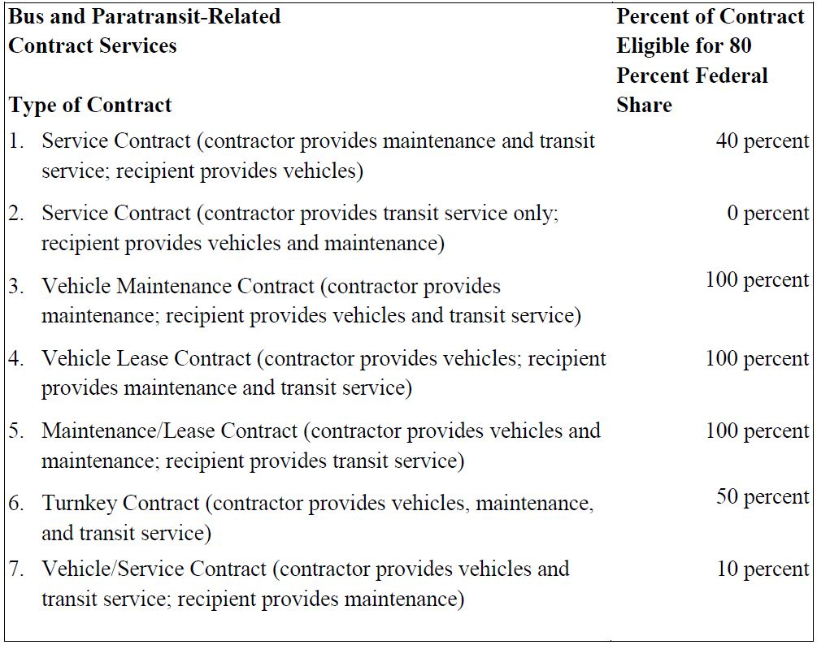

*Source FTA Circular 3090.1E IV-12*

In essence, the Capital Cost of Contracting (CCoC) allows for various percentages of the contract to be considered Capital Costs, allowing for a higher federal match, which in turn reduces the required local match amount.

Below is a walkthrough of the CCoC Scenario 1 “Service Contract,” where the contractor provides the maintenance and service, and the recipient provides the vehicles. The cost figures are from the Valdosta Transit Implementation Study (2016), completed by the firm Tindale Oliver, and use their low estimates for planning purposes.

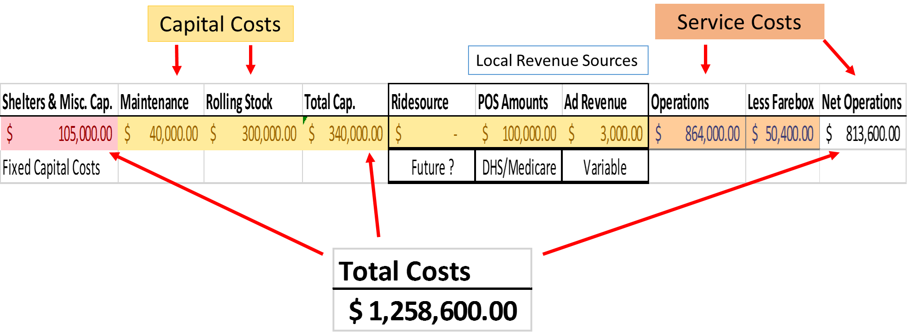

Figure Capital Cost of Contracting Planning Figures

The Fixed Capital Costs include bus shelters, benches, signage, and administrative technology costs, things a contractor would typically not own. Additional Fixed Capital Costs eligible items can be found in Appendix C. These costs are primarily the responsibility of a local governmental entity. The Capital Costs include the maintenance and rolling stock that would need to be provided order to implement two fixed routes as outlined by the Tindale Oliver Study. These figures account for five 15 passenger cut-away buses at $60,000 each and 13% annual maintenance costs of $40,000.

The Service Costs also come from the Tindale Oliver Study, where $720,000 is the estimated cost of the fixed routes, and an additional 20% of the fixed route costs, or $144,000 are used as complementary paratransit costs. The Farebox Revenue is estimated using a 7% recovery rate of operating costs, and is deducted from the operating costs before Federal assistance is applied. The Local Revenue sources factor in later for local operating estimates.



In Scenario 1, the Contractor provides the Maintenance and Service, making them eligible for the CCoC formula to apply, and the Vehicles are the responsibility of the Recipient. The costs for each scenario are broken down between the Federal, State, and Local levels to provide a clear understanding of financial obligations.



Figure Scenario 1 Capital Costs

In Scenario 1, the Recipient is responsible for providing the Vehicles. This is considered a traditional Capital Cost, and costs are accounted for at an 80%/10%/10% split between Federal, State, and Local entities, respectively. This equates to $240,000 provided at the Federal level, $30,000 provided at the State level, and $30,000 provided at the local level.

These costs are combined with the Fixed Capital Costs of $105,000, or $84,000 at the Federal level, $10,500 at the State level, and $10,500 at the local level.

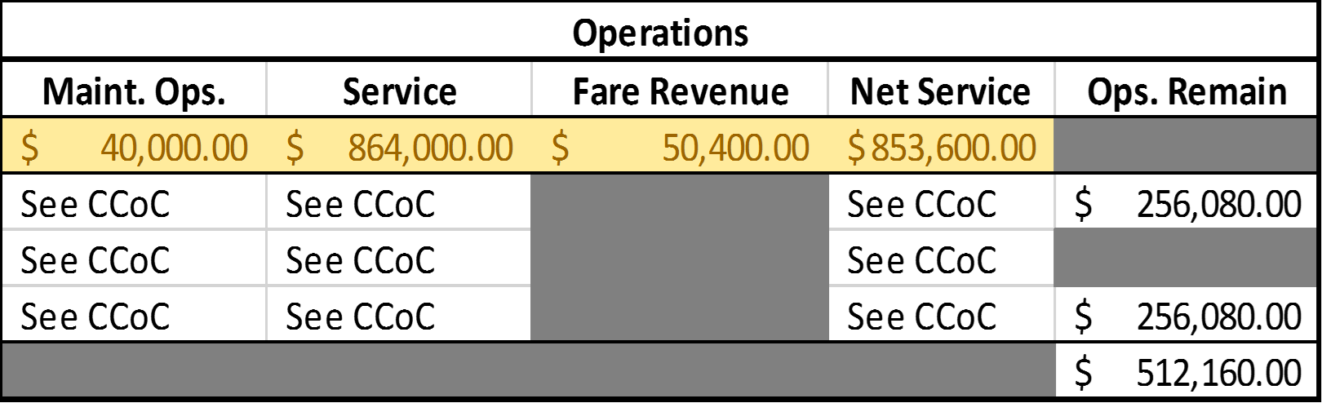

Figure Scenario 1 Operational Costs

In Scenario 1, since the Contractor is providing the Maintenance and Service, these costs are considering Contracted Costs and are eligible for the CCoC Formula to apply. The Maintenance and Service Costs, less the Fare Revenue equates to $853,600 in contracted costs.

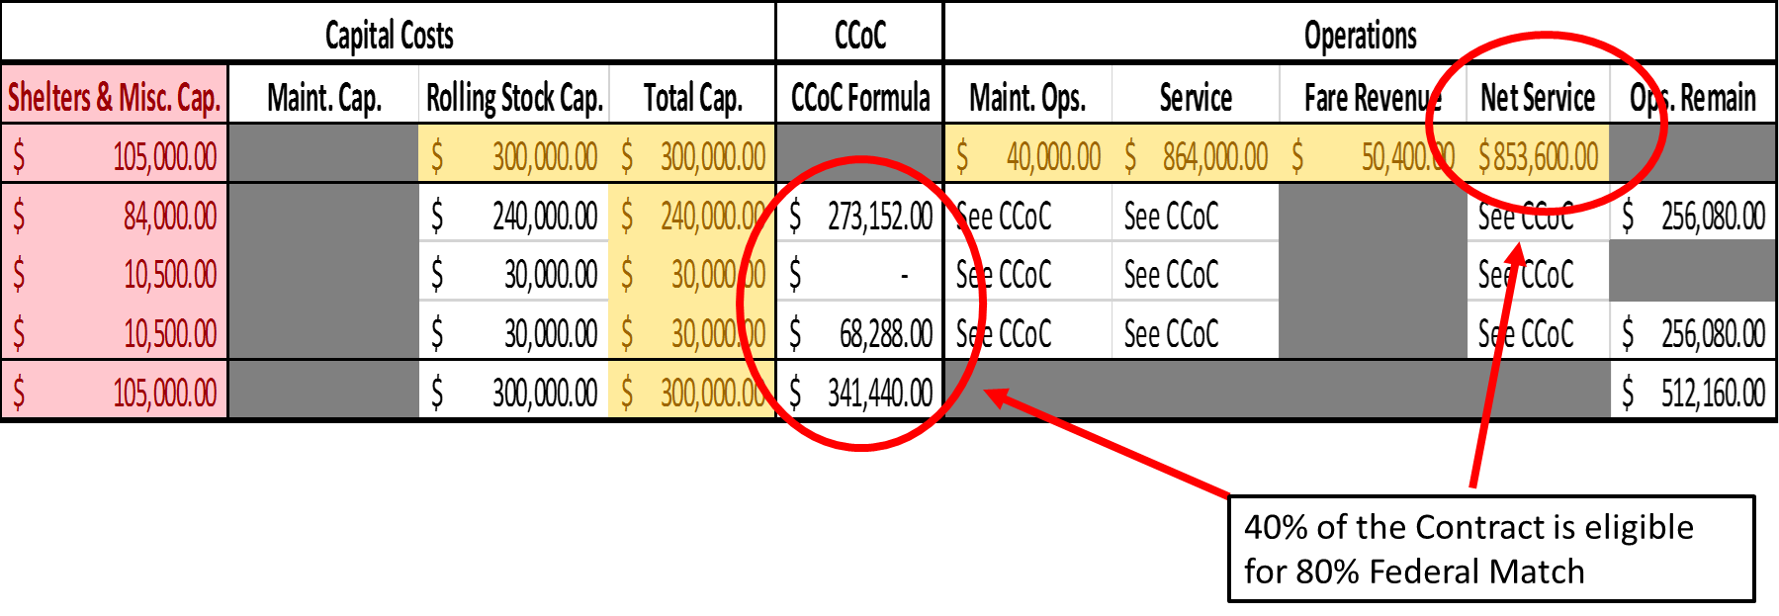

Figure Scenario 1 Capital Cost of Contracting Formula

In Scenario 1, 40% of the contracted costs are able to be receive the 80% Federal level match. This computes to $273,152 of the contracted service being paid by Federal funds, and $68,288 required from the local governmental entity.

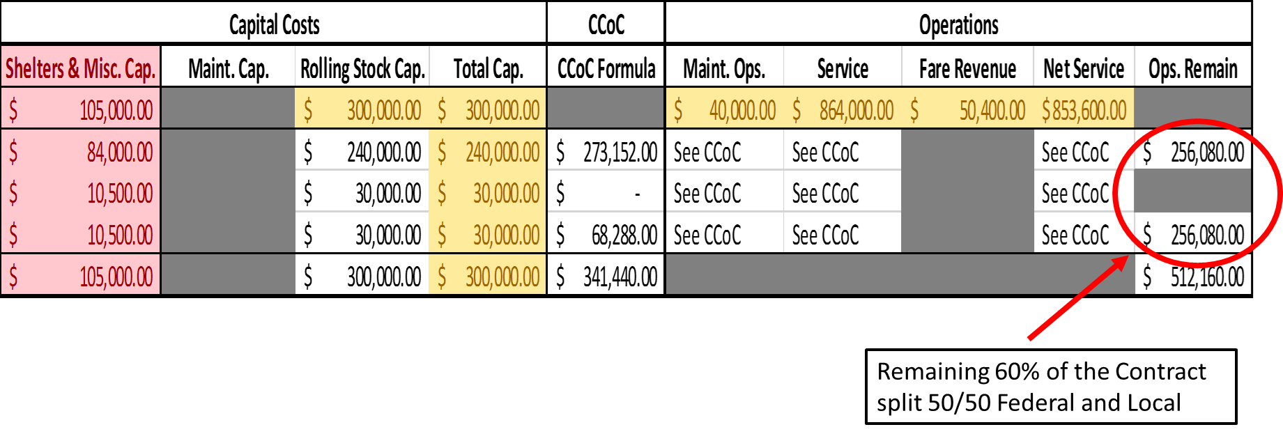

Figure Scenario 1 Capital Cost of Contracting Remaining Operations Formula

This still leaves 60% of the contracted costs that are not eligible for the CCoC formula, or $512,160, that must be split between the Federal and Local level at a 50/50 match requirement. This breaks down to $256,080 of Operating Costs that must be covered by the Federal and Local governmental entity.

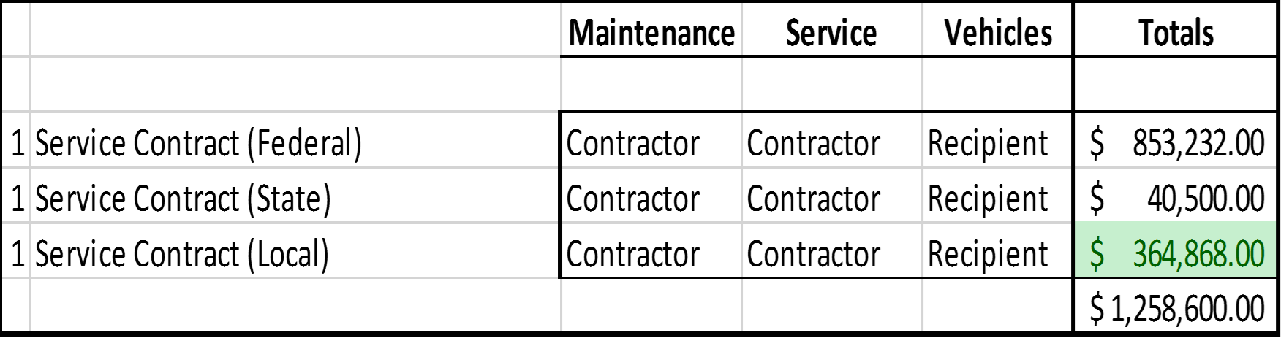

Figure Scenario 1 Financial Obligation Breakdown

In Scenario 1, the financial obligation breakdown is as follows: $853,232 at the Federal level, $40,500 at the State level, and $364,868 at the Local level. These figures include the Fixed Capital Costs, Capital Costs of Contracting, Traditional Capital Costs, and Operating Costs.

All 7 scenarios listed under the Capital Cost of Contracting table, as well as an 8th scenario where a local entity provides the vehicles, maintenance, and service were computed using the same costs in Figure 13 on page 33, and their financial obligation breakdowns are listed in Appendix D.

Included in Appendix E are 5-year Capital and Operating estimated budgets for each scenario. The costs assume a 2.32% annual inflation rate, and a 4-year useful vehicle life.

It must be noted that the costs used were planning level figures, and subject to change dependent upon any given number of variables. An example of these variables is the type and costs of vehicles used to provide the service. While the Tindale Oliver study recommended five 15-passenger vehicles, a contractor or local entity may decide to use a smaller or larger vehicle, which could drastically change the costs and scenario outcomes. A smaller 10 passenger vehicle might cost $30,000, whereas a larger 30-passenger vehicle might cost upwards of $200,000. Additionally, the fuel type used in each vehicle could have an impact on operational and maintenance costs, as diesel, compressed natural gas, and electric or hybrid vehicles may require additional infrastructure or specialized service technicians.

The Local Share

In addition to the 5307 funds, there are several revenue streams available to help offset the financial obligation at the local level, further reducing the local cash amount required by a local entity. This section will describe these options and how they might be able to be implemented in a transit service in the Valdosta Urbanized Area.

Innovative Options

The first is Purchase of Service (POS) revenue from contracts through other agencies or businesses. This would include funds from the Department of Human Services Coordinated Transportation program, as well as Medicare/Medicaid, and other social service agencies. Currently, the Lowndes County Rural On-Demand Transit system is receiving and using POS revenue to meet the local match requirement for the 5311 funds. Any POS funds used for an urban transit system may have an adverse impact on the funding currently used for the rural system in Lowndes County, utilization of this funding mechanism should be further researched for impact on local transit programs before implementation. (FTA Circular C 9030.1E IV-15)

The City of Valdosta receives an annual Community Development Block Grant (CDBG) based on their population. For 2016 this amounted to $576,889. All or a portion of this grant could be used as local match in funding an urban transit system. Whether to utilize the CDBG, and how much it to use, would be an opportunity cost decision left up to City of Valdosta officials. (FTA Circular 9030.1E III-9)

The second is through partnerships with either local businesses or authorities, or with educational institutions like South Georgia Medical Center, Wiregrass Georgia Technical College, and Valdosta State University (VSU). VSU is an organization that could benefit from improved transit service and may be open to a partnership. For example, a more robust local transit system could reduce the need for parking on campus, saving VSU capital and maintenance costs associated with parking structures and lots, or allowing the university to redevelop underutilized parking facilities for classrooms, laboratory space, or other academic purposes. In partnering with VSU, there may also be an opportunity to report trips on the internal VSU transit system to NTD, and therefore count those trips in the Section 5307 funding formula.

The University of Georgia (UGA) in Athens is an example where the college contracts with the Athens Transit System (ATS) to provide service to students and citizens alike. This partnership allows for a higher level of mobility for students, improves operational efficiency by minimizing duplicated services, and lessens road congestion and maintenance costs to local governments. UGA uses student fees to pay ATS on a monthly basis, which reduces the local match amount required. Other transit agencies across the country are partnering with private businesses or authorities willing to self-impose transit tax districts to attract more employees, or contract with apartment complexes, which include a pre-paid transit pass as one of their amenities.

A third option includes revenues from local advertisement sales. This could include ad space inside the vehicles, on benches or shelters at stops, or through targeted push notifications on smart devices. (FTA Circular 9030.1E III-11)

Tax Options

Local funding for transit in Valdosta can, and should, come from a blend of diverse sources, one of which may be a local option sales tax. For the voters to approve an additional tax for transit, numerous governmental and non-governmental partners would have to work together to “make the case” to the voters on the importance and reasonableness for supporting transit investment in their community.

Lowndes County and its municipalities currently have a special purpose local option sales tax (SPLOST) in place that runs through December 31, 2019. Historically, the SPLOST in Lowndes County has provided revenues of approximately $20 million per year, and a portion of this funding has been used for various capital expenditures that have included transportation related projects. Because the SPLOST project list is approved in advance, there is no opportunity to fund a transit system through the current SPLOST. However, purchases of vehicles and other capital improvements for a transit system could be included on future SPLOST project lists.

A regional or single county TSPLOST may provide an additional source of revenue. Anticipated revenues from a TSPLOST would vary greatly depending on the amount of tax (i.e., halfpenny versus full‐penny) approved by the voters, and the type of approved projects they would fund. Unlike the SPLOST, aside from a small portion remitted to the state as an administration fee, all revenues from a TSPLOST must be spent on transportation projects. Should a TSPLOST referendum be placed on the ballot and approved by voters, this funding source has the potential to meet capital needs as well as provide a local operating match each year for transit services.

## Technology and Ridesourcing

As technology has advanced, it has also impacted how individuals think about transportation and mobility. These technological advances have led to the creation of “ridesourcing” companies, where individuals can request a ride from their smart device, and another individual can provide the ride for a small fee. The ridesourcing aspect that is part of the recommended transit implementation plan not only is appealing and innovative, but also is critical to the prospects of successful transit implementation in Valdosta. Thus, it may be possible for a Third Party Operator (TPO), such as MIDS Transportation, Tipsy Transit, Uber, 244-Taxi, or other private transportation companies, to add a ridesourcing feature to their family of transportation services.

Some cities are using a blended fixed-route/ridesourcing system to meet their transit needs. Citizens can hail a ride through an application, and then see options for any fixed route locations nearby, or choose to continue with the hailed ride. These preset fixed route services are offered in the mornings and evenings to help citizens commute to work, with a fixed price according to time and distance. Citizens may even elect to hail a ride to a fixed route pickup point, depending on their location.

These ridesourcing options might appeal to the approximately 20,000 residents who live within the urbanized area that are outside the Valdosta City limits. This includes residents in Hahira, Remerton, Moody A.F.B., and several unincorporated areas of Lowndes County. While the majority of these locations are outside the geographical area of the proposed fixed routes, they should still be considered when evaluating the ridesourcing and demand response type trips.

## Conclusions

Aside from Valdosta State University’s on-campus bus service, Valdosta has not had fixed-route public transit since 1963, when a locally owned, private-sector bus company ceased its transit operations. To begin exploring the feasibility of restoring fixed-route transit to Valdosta, the SGRC launched a “pilot shuttle” service in October of 2015. Even though the Pilot Shuttle was limited to one vehicle running a single loop on 90-minute headways, its ridership grew steadily, and indeed has helped illustrate the viability of transit in Valdosta.

With respect to commuting, it is worth noting that several of Valdosta’s larger employers have high concentrations of employees at a single site. Moody Air Force Base, South Georgia Medical Center, Fresh Beginnings/eLead1, and Valdosta State University account for 33% of all Lowndes County workers. These popular locations represent ideal transit destinations for an urban system.

Transit can also connect Valdosta residents with jobs and economic activity. As the experience with the pilot shuttle indicated, the opportunity for transit to be the linkage to employment is especially true for lower-wage workers and for adults who have not been able to maintain a steady work history in the absence of transit. The presumably modest investment that local governments might have to make in supporting transit that links otherwise-unemployed individuals to their jobs is far less than the cost of providing housing and supportive services to adults whose lack of transportation is the primary reason they are not in the workforce.

Transit can provide valuable mobility to others in Valdosta, in addition to workers. For instance, many in the Valdosta State University community do not have, or cannot afford to use, a personal vehicle. While the VSU shuttle service provides a high level of service on campus, its off-campus connections are limited, even though many students live off-campus. People who live in households without a personal vehicle are another key audience whose lives are much improved by the availability of transit.

The priority of this transit service should be to see that individuals in Valdosta are able to access their jobs and improve their ability to live and shop independently in the area. In promoting the case for establishing an urban transit service in Valdosta, local officials and current transportation stakeholders should continue emphasizing the message that it would be building on the current demand-response transit service provided by Lowndes County, the fixed-route bus service provided on the VSU campus, and the successes of the pilot shuttle program to carry out the Common Community Vision of providing regional connectivity to global economic opportunities through an efficient, safe, accessible, and affordable multi-modal transportation system.

# References:

U.S. Department of Transportation Federal Transit Administration. (January 16, 2014). Circular 9030.1E. *Urbanized Area Formula Program: Program Guidance and Application Instructions*. Retrieved from www.transit.dot.gov/regulations-and-guidelines/fta-circulars/final-circulars

National Center for Transit Research. (July, 2014). *Cost-Benefit Analysis of Rural and Small Urban Transit.* Retrieved from [www.nctr.usf.edu](http://www.nctr.usf.edu) database.

Tindale Oliver. (2016). *Valdosta Transit Implementation Study*. Valdosta, GA, 2016.

Zeilinger, Chris. (2066). *Transit Implementation in Valdosta: CTAA Observations.* Washington, DC, 2016

# Appendix A: Monthly Ridership Statistics

# 

































# Appendix B: Transit Agency Profiles

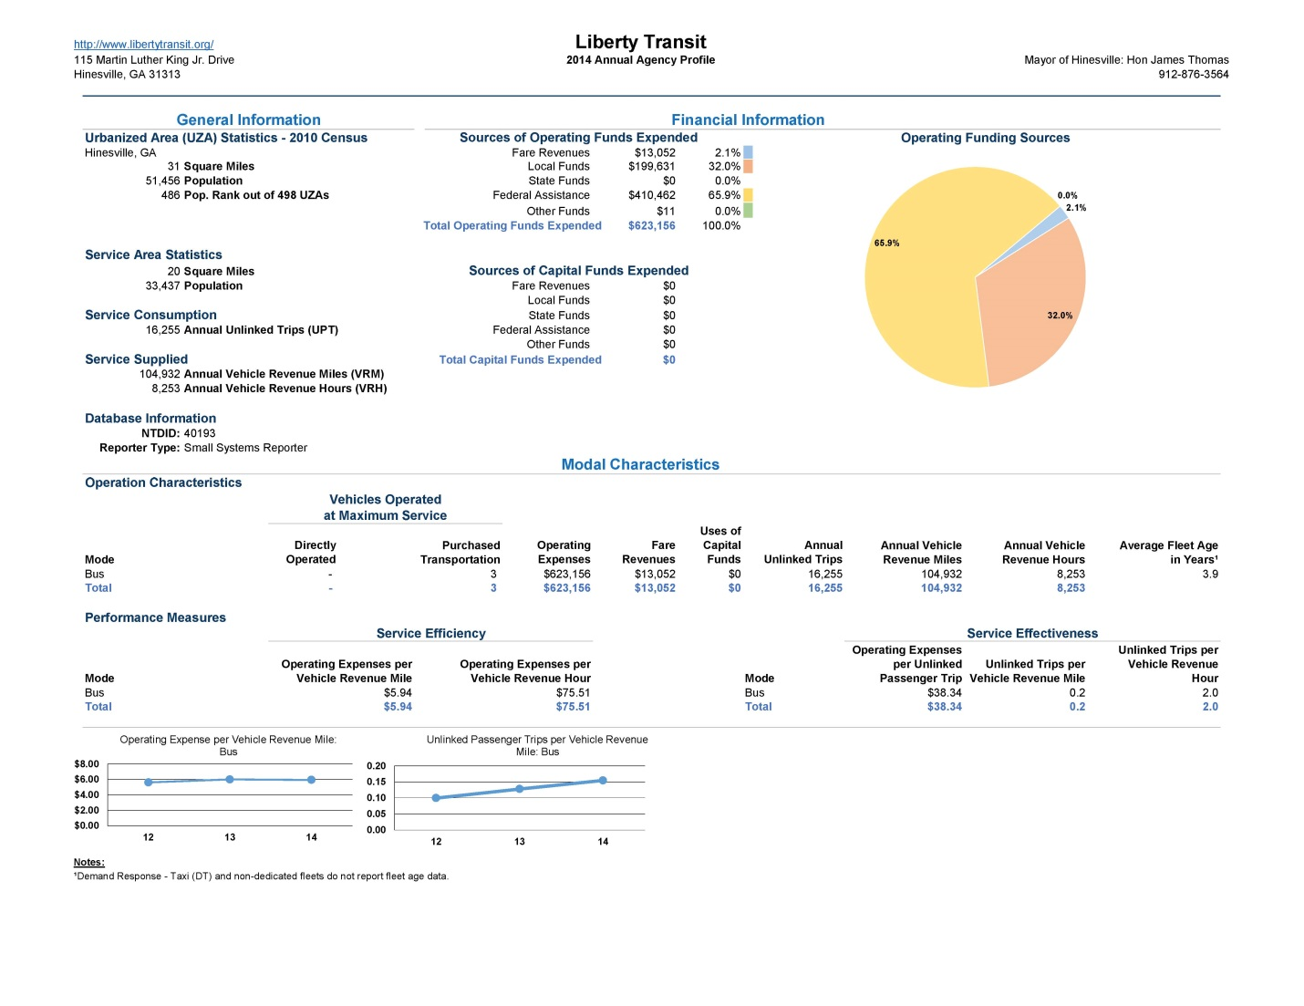

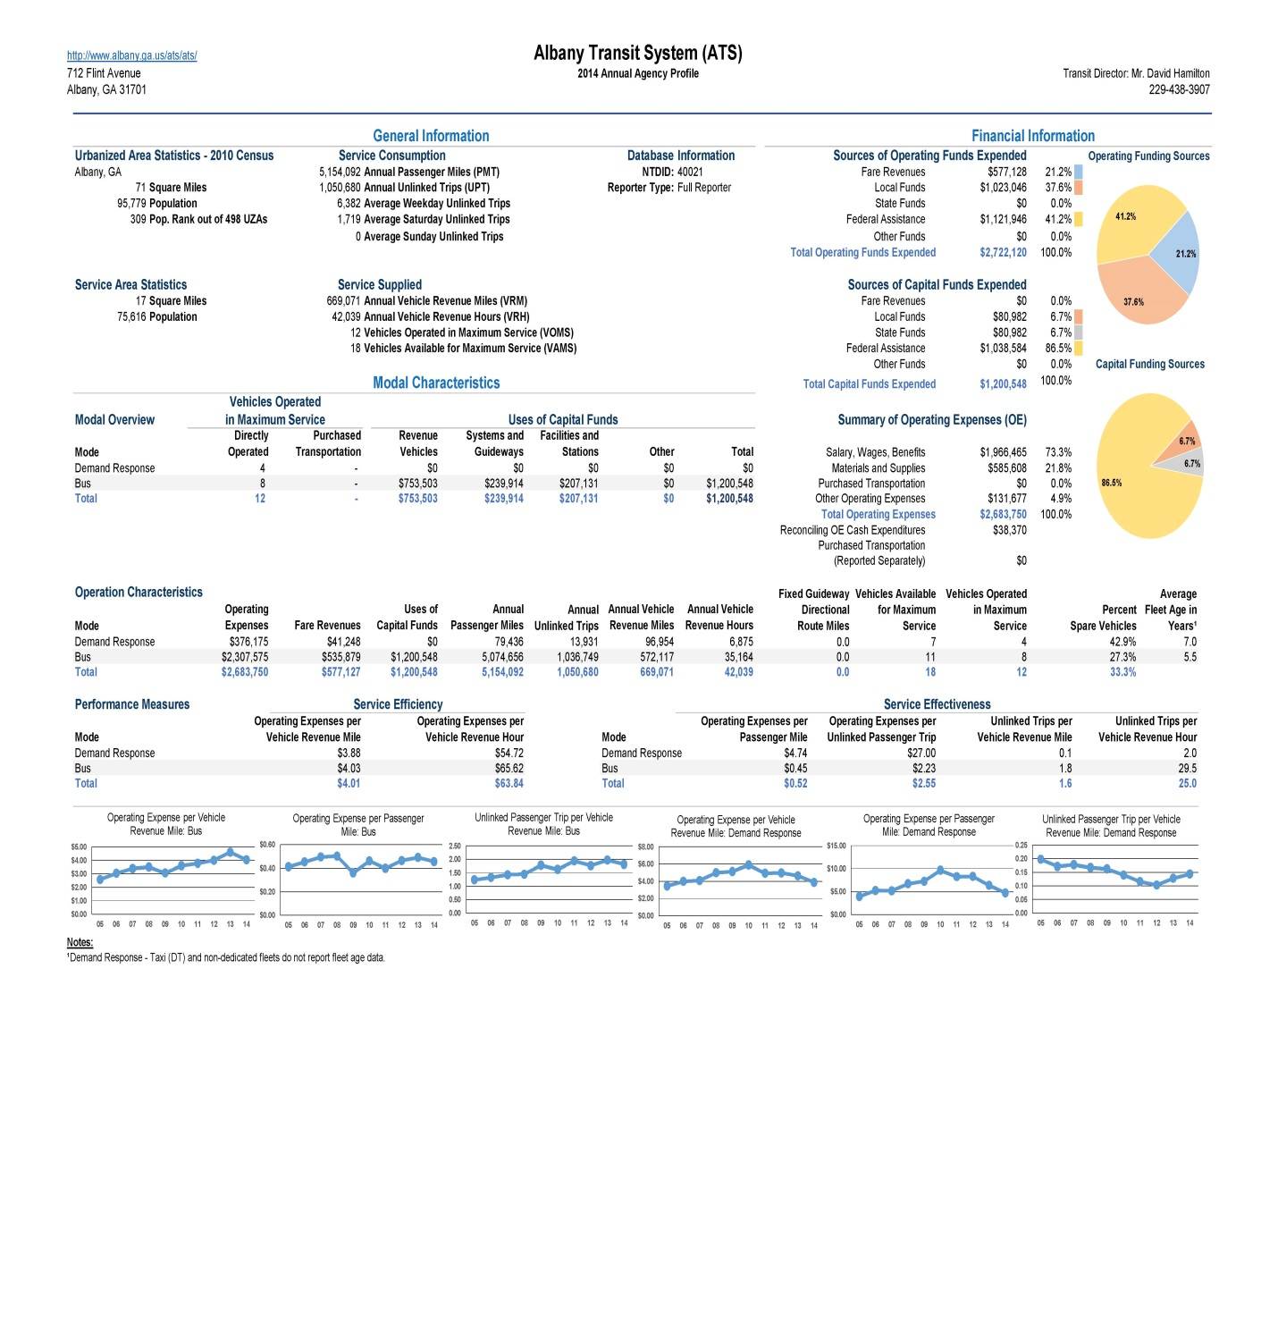

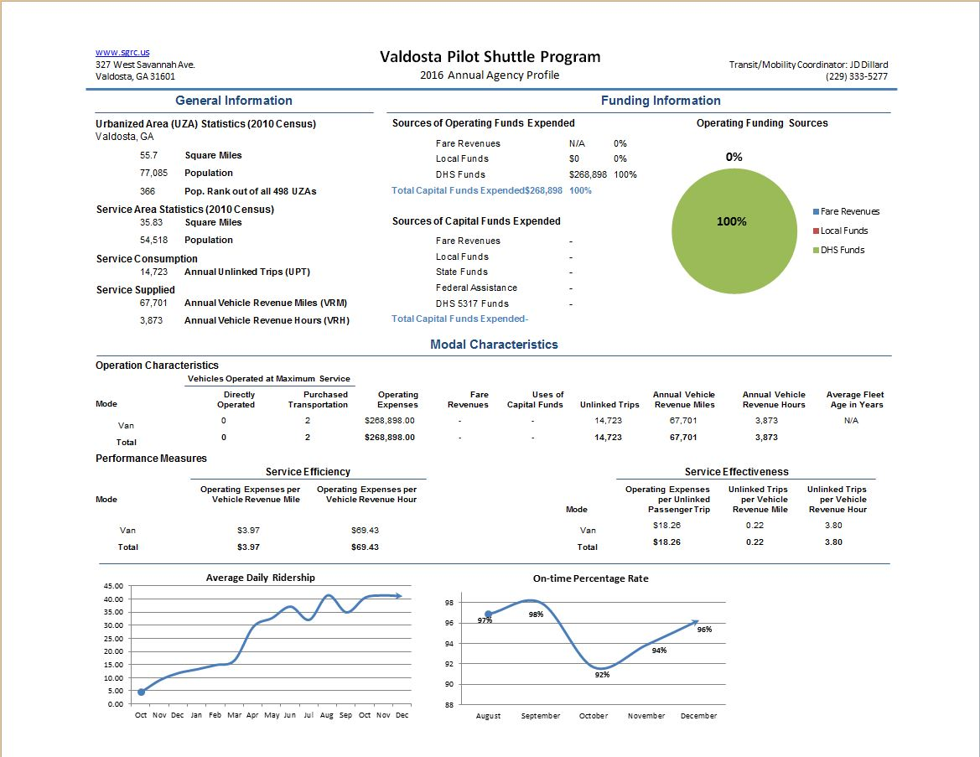

# Appendix C: Other Uses of 5307 Urban Transit Funds

FTA 5307 funds can also be applied to “associated transit improvements” which includes projects or project elements that are designed to enhance public transportation service or use and are physically or functionally related to public transportation facilities. This category of projects was formerly known as “transit enhancements.”

(1) The following public transportation projects and project elements qualify as associated transit improvement projects:

(a) Historic preservation, rehabilitation, and operation of historic public transportation buildings, structures, and facilities (including historic bus and railroad facilities) intended for use in public transportation service;

(b) Bus shelters;

(c) Landscaping and streetscaping, including benches, trash receptacles, and street lights;

(d) Pedestrian access and walkways;

(e) Bicycle access, including bicycle storage facilities and installing equipment for transporting bicycles on public transportation vehicles;

(f) Signage; or

(g) Enhanced access for people with disabilities to public transportation. Associated transit improvement projects or elements of projects designed to enhance access for people with disabilities are required to exceed the minimum requirements of the ADA.

(2) Bicycle and pedestrian paths within a certain distance from a transit stop or station are eligible capital projects and qualify as associated transit improvements. Pedestrian paths located within 0.5 miles of a transit stop or station and bicycle paths located within 3 miles of a transit stop or station are eligible capital projects. Projects outside this distance may be eligible if they are within the distance that a person could be expected to safely and conveniently walk or bicycle to the particular stop or station.

# Appendix D: Local Financial Obligation Breakdowns by Scenario

|  |  |  |
| --- | --- | --- |
|  | **% of Contract Eligible for 80% Federal Share** | **Local Totals** |
| **Scenario 1** | 40% | $ 364,868.00 |
| **Scenario 2** | 0% | $ 451,300.00 |
| **Scenario 3** | 100% | $ 455,300.00 |
| **Scenario 4** | 100% | $ 481,300.00 |
| **Scenario 5** | 100% | $ 485,300.00 |
| **Scenario 6** | 50% | $ 414,260.00 |
| **Scenario 7** | 10% | $ 537,892.00 |
| **Scenario 8** | N/A | $ 451,300.00 |

# Appendix E: 5 Year Estimated Local Capital and Operation Expense Budgets



